Compilation and Running Instructions

# Overview

This document explains the detailed steps to extract the archive, compile and build the code; and run the coding challenge “People Name Program 1.0”.

# Compressed File Contents

A compressed file named **ArielRodriguez_PeopleNameProgram.zip** is provided with this document contains the following:

* A directory named **arielrodriguez.peoplenames** which contains the Java project structure with:
  + A directory named **src** which contains the Java source files for the application and the JUNIT tests.
  + The file **pom.xml** which is used to compile and build the project.
* A directory named **input_file** which contains the text file **coding-test-data.txt** provided to validate the code.
* A directory named **output_file** which contains a text file with the output for one clean run using the **coding-test-data.txt** file as input.

# Compilation & Build Instructions

1. Extract the compressed file **ArielRodriguez_PeopleNameProgram.zip** on your preferred location on a computer that has Java and Maven installed.
2. Navigate to the directory **arielrodriguez.peoplenames** and run the command to compile:

mvn compile

Expected output:

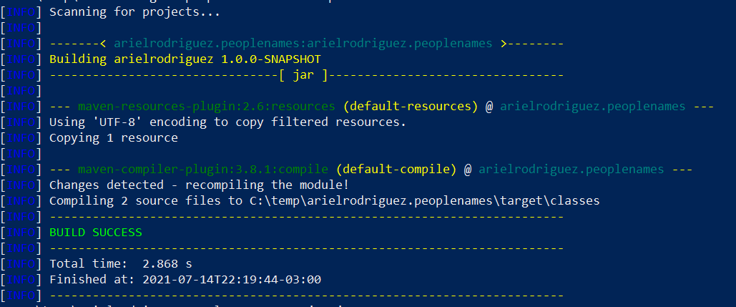

1. Run the following command to build the Jar file:

mvn jar:jar

Expected output:

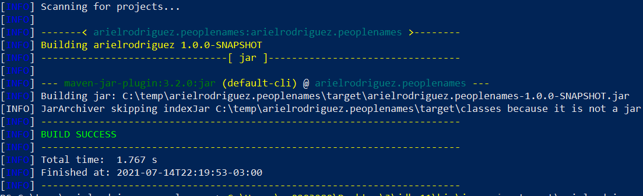

The output of these commands will be the file **arielrodriguez.peoplenames-1.0.0-SNAPSHOT.jar** in the folder **arielrodriguez.peoplenames\target** along with other binaries.

# Execution Instructions

1. Invoke using Java the newly built **arielrodriguez.peoplenames-1.0.0-SNAPSHOT.jar** with the following parameters:

* Path and name of the input file
* Number of modified names to print

In this format:

java -jar arielrodriguez.peoplenames-1.0.0-SNAPSHOT.jar <Input_File> <Number_Modified_Names>

Example:

